BENCHMARKING:

RABBITMQ V/S KAFKA

# Heading 1

To get started right away, just click any placeholder text (such as this) and start typing.

To apply any text formatting you see on this page with just a click, on the Home tab of the ribbon, check out Styles.

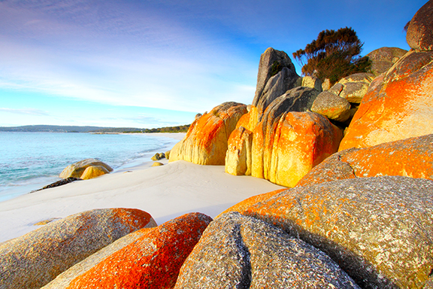

Want to insert a picture from your files or add a shape or text box? You got it! On the Insert tab of the ribbon, just click the option you need.